**Homework 2**

**Classical & Operant Conditioning**

**In the below scenarios, identify the US, UR, CS, and CR.**

1. Imagine you are playing a video game. The frequent appearances of the spooky antagonist create a significant startle response for you each time it emerges from the shadows. Prior to each appearance of the antagonist, you begin to notice the sound of static can be heard nearby. Soon, each time you hear the static noise in the game, you become afraid.
   1. US: Spooky antagonist that’s larking in the shadows
   2. UR: You feel startled or afraid
   3. CS: Hearing static noise
   4. CR: You feel startled or afraid
2. Brian’s new puppy keeps running into the street outside his house. Brian decides to install an invisible fence that administers a small shock when the puppy runs into it. After a few times of being shocked, the puppy now exhibits fear and avoids the boundaries of the yard near the invisible fence.
   1. US: Runs into the invisible fence
   2. UR: Getting a small shock
   3. CS: The boundaries of the yard near the invisible fence
   4. CR: Getting a small shock
3. Every summer, the ice cream truck plays its music and comes to the park that Kara frequents. One evening, Kara decides to buy an ice cream cone. When she eats it, she feels relaxed and happy. She indulges in an ice cream treat several times that summer. By the end of the summer, she notices that hearing the music of the ice cream truck brings back that same feeling of contentment.
   1. US: Eating ice cream during summer
   2. UR: Feels relax and happy
   3. CS: Hearing the ice cream trunk music
   4. CR: Feels relax and happy
4. Pebbles the cat loves canned tuna and gets excited every time she eats it. Her owner uses an electric can opener to open the tuna cans. Now whenever Pebbles hears the sound of the can opener buzzing, she comes running into the kitchen.
   1. US: Being fed canned tuna
   2. UR: Gets excited
   3. CS: Hears the can opener buzzing
   4. CR: Gets excited

**Classical Conditioning short answer:**

Provide an example of classical conditioning from your life, a video game, movie, book, or other media.

Be sure to identify the US, UR, CS, and CR.

My friend, Luke, and I both like the “Yakuza” game series, a beat-em-up adventure game where you play as a character named Kiryu Kazuma who have to thwart conspiracies and threats to defend those he holds dearly, that being his friends and family.

The series has span multiple games and spin off but the one I’m focusing on is the first game’s English dud version. In this game, the antagonist, Akiyama Nishikiyama, says a line which has become a meme for those in the community. I can’t really say it here cause vulgarities but here’s the clip of him saying it

<https://www.youtube.com/shorts/ubCWYRIZ23k>



**“10 years in the joint” sound clip**

The thing about this audio clip is that Luke and I are in an online group on an app called Discord in which we can join calls to talk with people and in this app, we can play audio clips via Discord’s Soundboard. And whenever Luke or I decide to join the call, we will play this sound clip.

So now whenever somebody joins a call, if this sound clip was played, everyone knows it’s either him or me who just join the call.

US: Joining the call and saying hi to everyone

UR: Knowing that either me or Luke have entered call

CS: Hearing the sound clip being played upon joining the call

CR: Knowing that either me or Luke have entered call

**In the following scenarios, identify whether this is an example of positive reinforcement, negative reinforcement, positive punishment, or negative punishment. Answer the associated questions to help you arrive at your answer.**

1. Taking aspirin to get rid of a headache.
   1. What is the behavior being reinforced/punished? – Taking aspirin
   2. What is the consequence of the behavior? - Getting rid of headache
   3. Was a stimulus added or subtracted? – Subtracted (Negative)
   4. Does outcome increase or decrease the likelihood of the behavior being repeated? – Increase behavior being repeated (Reinforcement)
   5. Answer: Negative Reinforcement
2. A puppy gets yelled at for peeing on the carpet.
   1. What is the behavior being reinforced/punished? - Peeing on the carpet
   2. What is the consequence of the behavior? – Getting yelled at
   3. Was a stimulus added or subtracted? Added (Positive)
   4. Does outcome increase or decrease the likelihood of the behavior being repeated? – Decrease (Punishment)
   5. Answer: Positive Punishment
3. A homeowner gets rid of termites by calling an exterminator.
   1. What is the behavior being reinforced/punished? – Calling the exterminator
   2. What is the consequence of the behavior? - Getting rid of termites
   3. Was a stimulus added or subtracted? – Subtracted (Negative)
   4. Does outcome increase or decrease the likelihood of the behavior being repeated? – Increase (Reinforcement)
   5. Answer: Negative Reinforcement
4. Parents take away their child’s Nintendo Switch because of a bad report card.
   1. What is the behavior being reinforced/punished? - Bad report card
   2. What is the consequence of the behavior? - Taking away the Switch
   3. Was a stimulus added or subtracted? Subtracted (Negative)
   4. Does outcome increase or decrease the likelihood of the behavior being repeated? – Decrease (Punishment)
   5. Answer: Negative Punishment

**In the following scenarios, identify whether this is an example of variable interval, variable ratio, fixed interval, or fixed ratio.**

1. You buy a soda from the vending machine. – Fixed ratio
2. The mailman delivers the mail every day at 2pm. – Fixed interval
3. Receiving emails to your email inbox. – Variable interval
4. Winning a prize from the claw machine. – Variable ratio

**Reading assignment:**

Read the article “Behavioral Game Design.”

Pick one part of the article that you found interesting (e.g. you found surprising, you agreed/ disagreed with, a tactic you’ve experienced, a tactic you’d like to incorporate into a game you create, etc.) and explain why.

In the article where they were discussing the “Recipes” on how to make the player play hard, it states that the answer is the use of variable ratio schedule.

This is true in many roguelike games where the player will usually have to go through a challenge to be able to attain an unknown reward at the end of the bout. Games like Gunfire Reborn and Hades use this idea in their game mechanic although Hades adds a mix of fixed ratio in a sense which, personally, goes together with variable ratio.

This is because, unlike other rouge like games, Hades combines the element of fixed ratio and variable ratio which help it stand out from other games

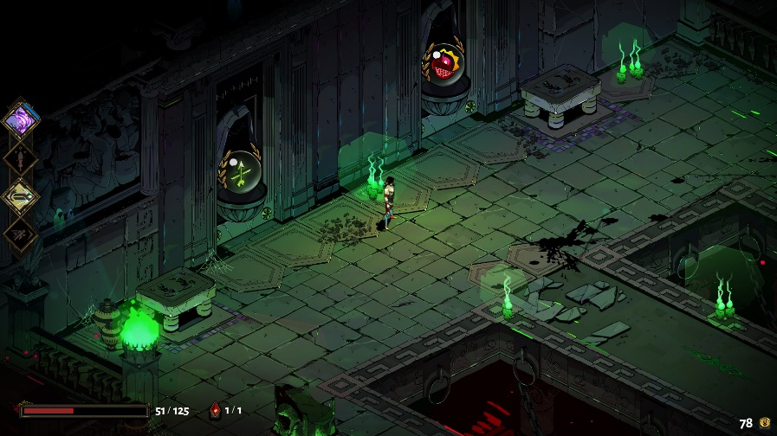

Take this image for example. On the left, you can get something called a “boon” which can grant you a new ability that’s specialize for a certain build or play style. For this case, the left boon specializes in crit chances. The right boon, however, upgrades an existing ability you already have.

So, in terms of Fixed ratio, when you complete that room, you will get a reward of that type so you’ll know what to expect. The variable ratio of this part comes in when you collect the reward. Because you have only 3 choices to pick from.

So now you must pick which of the 3 choices here are the best both in the short term and in the long term for this run as some ability can be stack on top or against one another.

So, although an element of fixed ratio is present which gives the player the ability to know what the outcome is going to be, the usage of variable ratio ensures that the player won’t get bored due to the game’s predictability as the choices given may or may not be to their liking thus forcing them to work with what they must ensure the best possible outcome occurs.